Chapter 16, Problem 70.

Using Fig. 16.93, design a problem to help other students to better understand how to do circuit analysis with circuits that have mutually coupled elements by working in the s-domain.
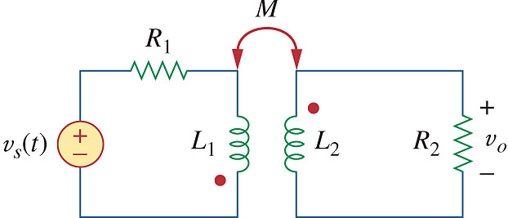

Figure 16.93
For Prob. 16.70.

